**Unit 1 Note Packet**

**6th Grade Science Skills and Methods**

Science is a way of gathering knowledge about the world around us. Scientists ask questions about the way the world works. They also design experiments to test their hypotheses. Scientists use special skills to help them in their search for knowledge about the things they are studying. You will need to know the following skills and methods this year in science class.

**Making Observations**

Making an observation is a process that uses your senses to gather information. When you make an observation, you use one or more of your five senses: sight, smell, hearing, taste and touch. Scientists rely on their senses to carry out controlled studies, experiments and investigations. In science observations may also be called “evidence” or “data.” Evidence is information or proof of something that can be observed such as color changes or behaviors. In science data are numerical facts and figures that are observed.

Some examples of data: 5 cm, 85°C, or 13 ml.

**Classification**

Many things are classified in science. When things are classified they are sorted or grouped by similar traits. A trait is a characteristic or quality that something has. For example, one characteristic of a leaf could be that it has jagged edges. The type of edges the leaf has is a trait. Scientists often use **Dichotomous Keys** to help them identify things. A dichotomous key uses pairs of statements which lead to other pairs of statements until a specific answer is determined for an unknown object. These keys help scientists identify many different kinds of things like birds, trees, rocks, shells, etc.

**Making Inferences**

An inference is a logical explanation based on observation and knowledge. Scientists observe and use their knowledge of science and past experiences to explain what they are observing. Some inferences end up being right and others are found to be incorrect. Inferences help scientists formulate questions that can be tested in an experiment.

**Measurement**

**Length**: Scientists often need to measure length, width and height as part of their scientific investigations. The metric system is the universal system for making measurements in science. The meter stick and the metric ruler are used to make measurements of distance. The units are based on the meter (m) which has 100 centimeters in it. To measure short distances or lengths, scientists use centimeters (cm) or millimeters (mm).

**Volume**: Volume is a measurement of the amount of space something takes up and the unit used is the liter (l). We often measure small amounts of liquids for science experiments. In this case milliliters (ml) are used.

**Mass:** Mass is the measure of the amount of matter or stuff that makes up an object. People often use the words mass and weight to mean the same thing. However, they are not the same. Weight has to do with the amount of gravity pulling on an object. In outer space, your weight would be different than on Earth, but your mass would be the same in both places. We measure mass in grams (g).

**Temperature**: Scientists use thermometers to measure the amount of heat that is present in a substance. In the United States, we still use Fahrenheit as our temperature scale when we refer to the weather. Many countries use Celsius for daily weather temperatures. Even so, the United States does use Celsius in science and technology. Therefore, you need to be able to read a thermometer in both Fahrenheit and Celsius. The units for measuring heat are degrees.

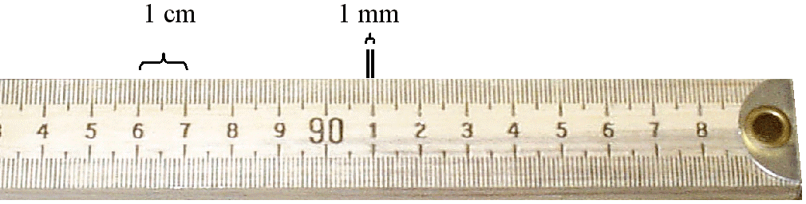

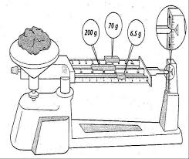

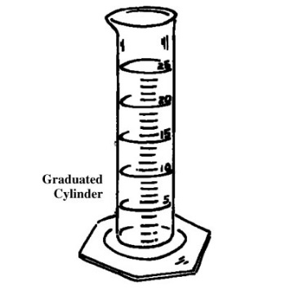

**The Scientific Method**

Scientists use a process called **The Scientific Method** to solve problems. The basic steps in the scientific method are:

1. **The Problem Question** – This is a scientific question that can be

tested. It is a specific question that is

answered after looking closely at the results

of an experiment.

Example: Will tomato plants grow taller in warm or cool

temperatures?

1. **Hypothesis** – This is a possible answer to a scientific question.

It is an educated guess based on observations and facts.

Example: If the temperature is kept warm then tomato plants will

grow taller than those kept in cooler temperatures.

1. **Experiment** – Experiments are used to test a hypothesis. They test

only one thing at a time. To be sure that only one thing

is tested at a time, variables are identified.

Observations and/or measurements are done during

experiments.

Example: (see the labs that we do in class for experiment procedures)

1. **Results** – The results is the data collected during the experiment.
2. **The Conclusion** – This is the answer to the problem question. This

answer comes from analyzing the data and/or evidence

that was gathered in the experiment. The hypothesis is

then found to be either right or wrong. If it is wrong, the

scientist formulates another hypothesis, and the process

of the scientific method is repeated.

Example: After doing several trials, I found that my hypothesis

was correct. Our data shows that tomato plants

grow tallest in warmer temperatures. Cooler

temperatures produced the shortest plants.

Scientists carefully identify different **variables** in the experiments that they design:

**Controlled variables** or **(Constants)** - These are the things that are kept the same throughout the experiment. This is to prevent unwanted things from affecting the results. There are often many of these in an experiment.

Examples: Keeping a technique the same throughout the experiment.

Keeping the starting point the same for all trials.

Keeping the temperature of the water used at 26° C

throughout the experiment.

Keeping the amount of sunlight each plant receives the same.

**Independent variable** or **(Manipulated variable)** - This is the **one** thing that is switched throughout the experiment. It is the thing you are testing and comparing.

Examples: Different brands of bubble gum.

The surface of different coins.

The type of exercise being done to increase

heart rate.

The temperature that tomato plants receive

**Dependent variable** or **(Responding variable)** - This is the thing you are looking for! You are observing this in the experiment. It is found after each trial is done. It is the result that is being measured, counted or noted. Your observations of this variable are recorded in the data table.

Examples: The length in centimeters that a ball rolled.

The number of drops of water that fit on the heads side of

a penny.

The color a liquid changes to after a chemical is added.

The height tomato plants grew.

**Experiments should include the following:**

1. A problem question
2. A hypothesis
3. A list of materials
4. A Procedure (which is a list of steps to follow)
5. Variables that are identified
6. Observations that are recorded in a data table for many trials
7. A conclusion

NOTE: a “trial” in a science experiment is not a court case! The number of trials refers to how many times the procedure for testing something is repeated. The more trials an experiment has the better its results will be. It is easier to identify (or see) patterns in the data when more data is collected and compared.

**Data Displays:**

Data (numerical observations) and/or evidence (observations such as color changes) are often organized and displayed in graphs, diagrams or models. These displays help to show the relationship between variables, which also helps the experimenter understand his or her results better.

**Making Scientific Models:**

Scientists develop and use models to help learn about the things they are studying. Models are representations of objects or systems. Models can be used to:

*represent things that are too small to see.

*represent things that are too large to see completely.

*explain the past, present and future.

There are three major types of models:

* Physical (can be touched): such as a world globe, map, solar system model,

or model of a volcano.

* Mathematical (equations and data): such as weather data, or genetic sequencing.
* Conceptual (systems of ideas/theories) such as “The Theory of Plate Tectonics” or

“The Big Bang Theory”.

Additional Notes: